Daily Report

Name of the Department: EIE Date: 31-March 2026

- Staff Attendance
S.No | Dept. | Category | On Rolls | Absent | Details/Remarks
1. | EIE | Teaching | 26 | 01 | Faculty – On Duty  1. Mr. P.V. Gopi Kumar  2. Mr. S.Bhargav  Faculty – Casual / Earn Leave  Full Day  - Ms. D.Shobana Priscilla  Half Day  Faculty – Half Pay Leave  Faculty - Study Leave  Faculty - Maternity/Paternity
2. |  | Non- Teaching | 06 | 00 | 0 Staff– On Duty  Name of the Staff  Staff- Casual / Earn Leave  Full Day  Half Day  00: On Vacation:  0 Staff– Half Pay Leave  - Name of the Staff  0 Staff -Study Leave  1. Name of the Staff

- Dr.S.S.Bharathi Sagi,Asst,Professor,EIE has filed a Patent with the title “Hardware - Deployable System and Method for Event Triggered Constraint-Preserving Computational Solution”, on 31-03-2026.
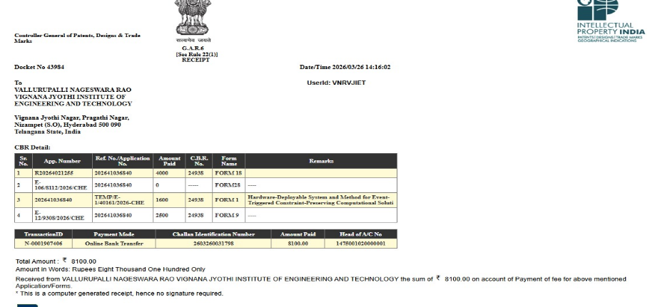
Event (short term course / workshops/Seminar, etc.) organized:
S.No | Name of the Event-Guest Lecture/seminar/ short term course / workshops,etc | Duration | For Whom | No. of Participants |  | Resource  Person/Faculty | Remarks
 |  |  |  | VNRVJIET | Others
1.
2.

Participation by Staff:

S. No | Name | Event | Status (delegate /paper) Present, speaker) | Date and Duration

Participation by Students:
 | Name | Event | Status (delegate /paper) Present, speaker) | Date and Duration
1

Staff joined or left.

S.No | Name of the Faculty | Designation | Date of Joining/leaving | Remarks

Classwork Adjustment / Lectures Interchanged:

S. No | Dept | Subject | Time | Adjusted from | Adjusted to

Incident if any (Discipline of staff or students, etc.)

S.No | Name | R. No. or ID No. | Brief statement | Remarks

Any other matter to be reported:

HOD–EIE

